**Assignment – 4**

**Python Basics**

Name: Suryapraba V

NM Id: au611220104159

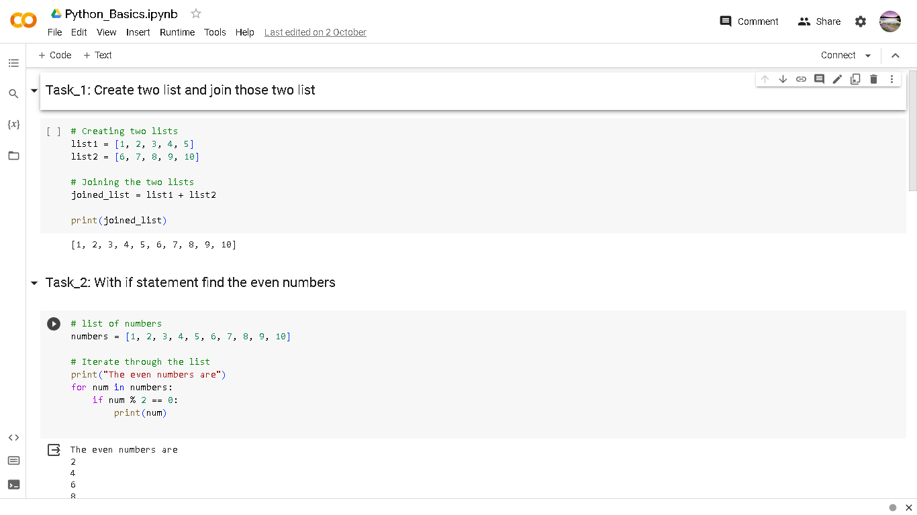

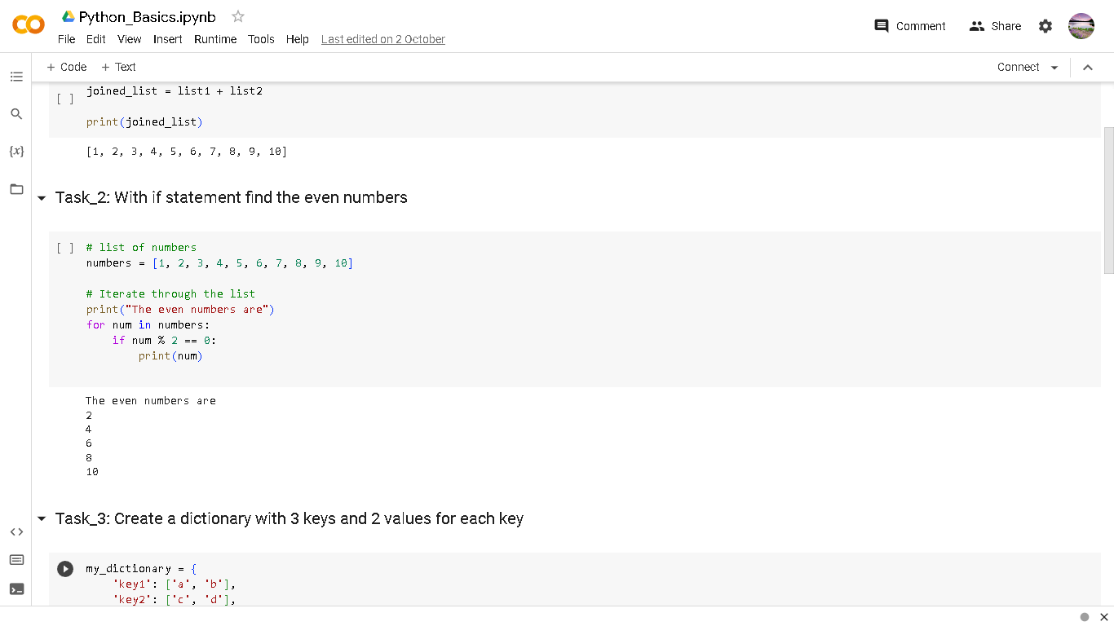

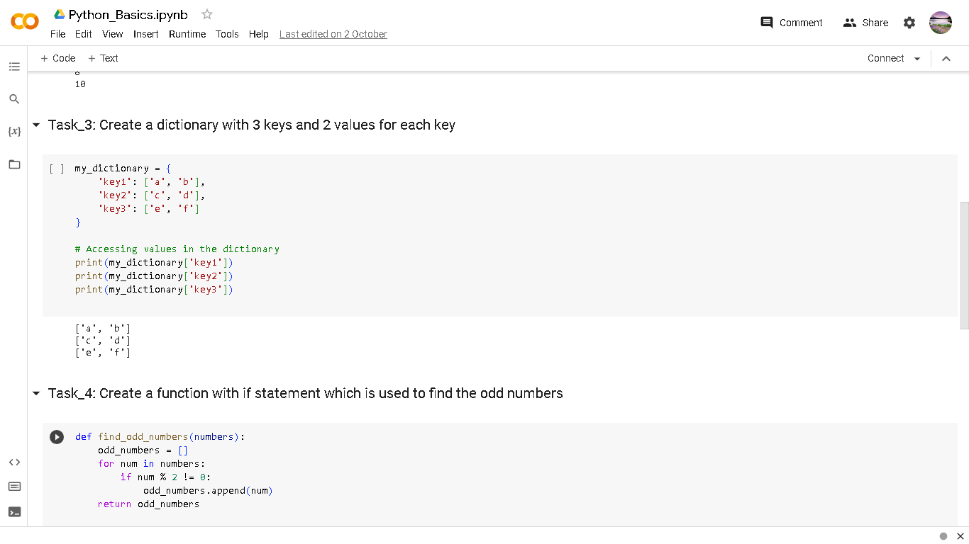

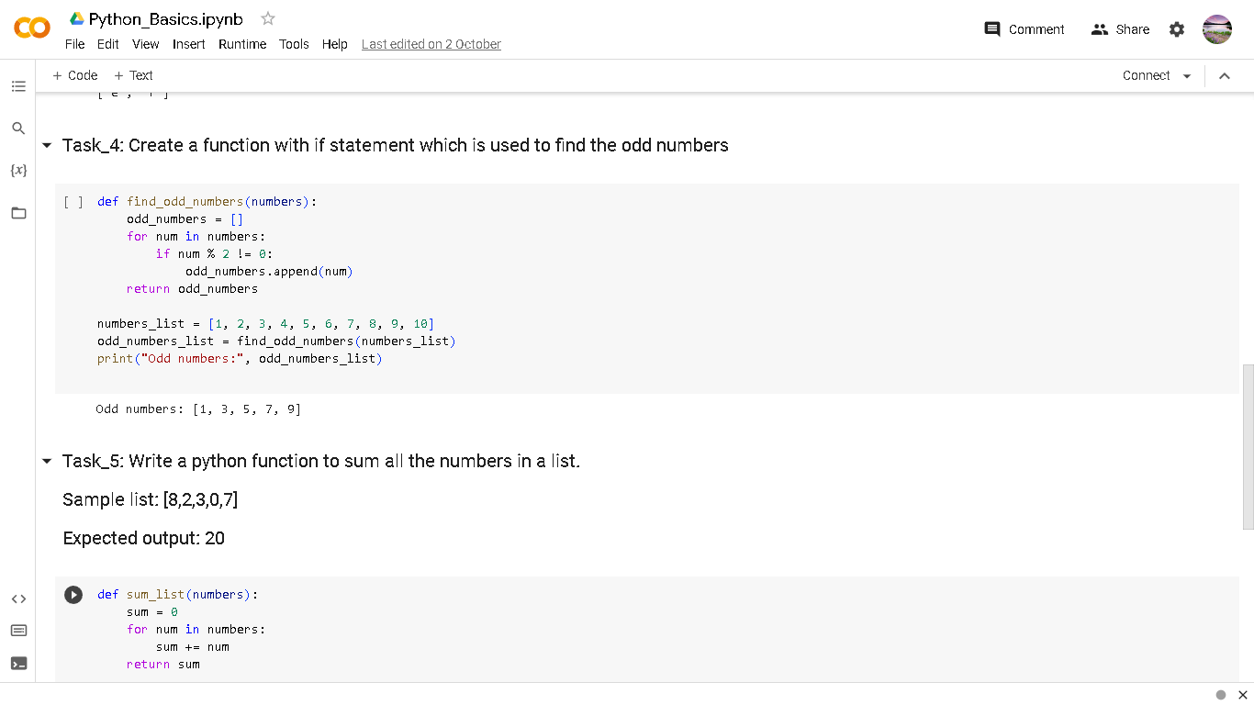

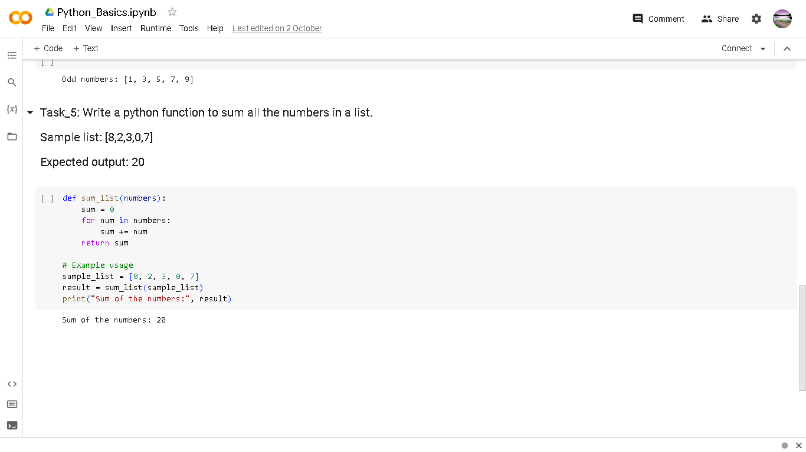

Python file Link:

https://colab.research.google.com/drive/1ZM3qabnh2Z3qBnimtQMgde5JLlj0uDcX?usp=sharing